Fraud Detection Case Study

Finding and Observations:

- Majority of transactions are of two type Payment and Cash-out. Cummulative both contributes approximately 69% of total transaction.

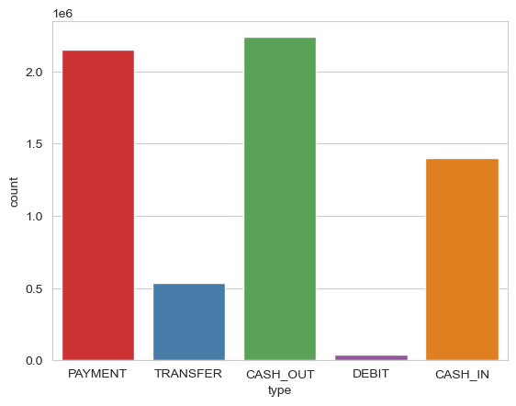

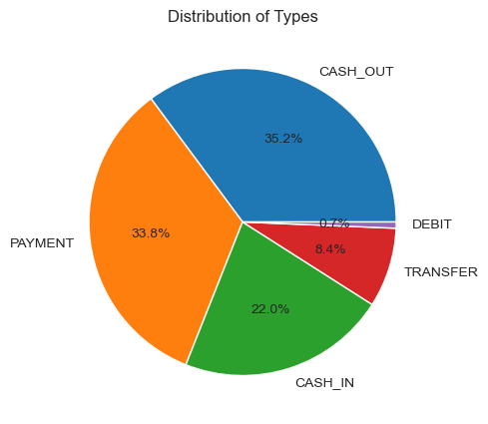

- The ratio of Not Fraud to Fraud is approximately 773: 1. i.e. For every 773 genuine transactions that occur, there is 1 fraud transaction that happens.

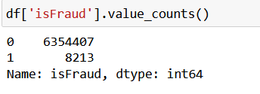

- We can infer that fraud transactions occurs mostly in Cash-out and Payment type

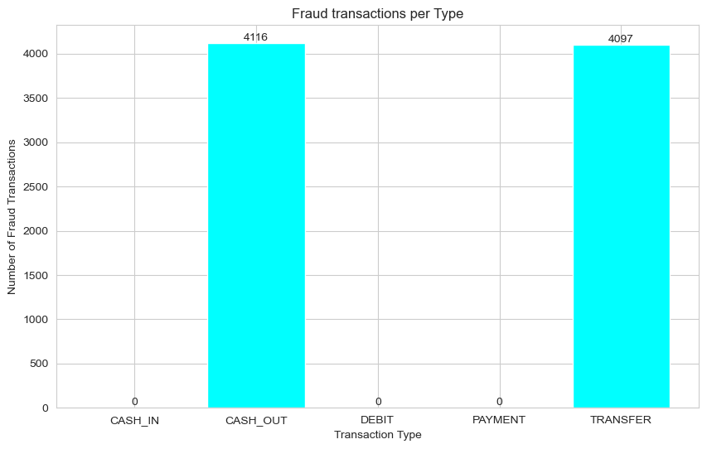

- Refer below accuracy table of different modelling algorithms

Sr No | Algorithm | Accuracy Score (upto 10 digits)
1 | Logistics Regression | 0.9992220186
2 | Decision Tree | 0.9994648430
3 | Random Forest | 0.9996448004
4 | KNN | 0.9995049209

It shows that Random Forest algorithm give higher accuracy

- Refer below Precision table of different modelling algorithms

Sr No | Algorithm | Accuracy Score (upto 10 digits)
1 | Logistics Regression | 0.7937576499
2 | Decision Tree | 0.7937576499
3 | Random Forest | 0.9473288186
4 | KNN | 0.8867635807

It shows that Random Forest algorithm give higher accuracy

After observing the results, we found that Decision Tree,Random Forest, KNN models have equal accuracy. However, Random Forest exhibits higher precision. In a fraud detection model, precision holds significant importance. The primary objective is to correctly predict fraud transactions while minimizing false positives for genuine transactions. Failing to achieve both these goals could lead to innocent customers being wrongly framed as culprits and guilty customers escaping detection.

This is one of the key reasons why Random Forest and is preferred over other alternatives in such scenarios.

Suggestion to Client

Prevention Measures to take by customers

1. Browse only on secured websites.

2. Download any applications from official app stores.

3. Use secured internet connections and avoid doing any banking transaction on public/free networks.

4. Keep your mobile and laptop security updated.

5. Don't respond to unsolicited calls/SMS/E-mails.

6. If customer feel like that they have been tricked or security compromised, contact bank at earliest.

